1. Utilizando un dataset, realizar análisis exploratorio de datos (EDA) con Pyspark aplicando los conceptos vistos en clase sobre gestión y análisis de datos en entornos Big Data.
Tareas sugeridas:
- Contexto y preguntas de análisis. Describan el origen y propósito del dataset y formulen preguntas que orienten su exploración.
Contexto
El archivo NetCDF contiene registros meteorológicos de alta frecuencia (521 200 timestamps) provenientes de una estación automática. Este tipo de datasets se usa para:
- monitorear condiciones atmosféricas,
- alimentar modelos de predicción climática,
- validar sensores,
- analizar variabilidad temporal.
El dataset incluye variables como:
- temperatura, presión atmosférica, humedad, velocidad del viento,
- voltaje del datalogger,
- variables QC (quality control) que indican si cada medición es válida.
Preguntas de análisis (EDA guiado)
- ¿Cómo se distribuyen las variables meteorológicas en el tiempo? – detectar tendencias, estacionalidad, picos.
- ¿Qué porcentaje de datos presenta problemas de calidad según las variables QC?
- ¿Existen valores extremos fuera del rango físico esperado?
- ¿Qué variables presentan mayor correlación? – ej. temperatura vs humedad, presión vs viento.
- ¿Qué tan completo está el dataset? – valores nulos, duplicados, gaps temporales.
Estas preguntas guiarán el EDA en PySpark.
2. Análisis de la estructura y metadatos del NetCDF
#Cargamos el NetCDF en el Google Drive
from google.colab import files
uploaded = files.upload()

import xarray as xr
ds = xr.open_dataset("/content/ARM_sgpmetE32.b1.2021.nc")
print(ds)
<xarray.Dataset> Size: 73MB
Dimensions: (time: 521200)
Coordinates:
* time (time) datetime64[ns] 4MB 2021-01-01 ... 2021-...
Data variables: (12/31)
base_time (time) datetime64[ns] 4MB ...
time_offset (time) datetime64[ns] 4MB ...
atmos_pressure (time) float32 2MB ...
qc_atmos_pressure (time) int32 2MB ...
temp_mean (time) float32 2MB ...
qc_temp_mean (time) int32 2MB ...
... ...
qc_logger_volt (time) int32 2MB ...
logger_temp (time) float32 2MB ...
qc_logger_temp (time) int32 2MB ...
lat (time) float32 2MB ...
lon (time) float32 2MB ...
alt (time) float32 2MB ...
Attributes: (12/28)
command_line: met_ingest -s sgp -f E32
process_version: ingest-met-4.42-0.el7
dod_version: met-b1-7.1
input_source: /data/collection/sgp/sgpmetE32.00/MET_Table1...
site_id: sgp
platform_id: met
... ...
qc_bit_2_assessment: Bad
qc_bit_3_description: Value is greater than the valid_max.
qc_bit_3_assessment: Bad
qc_bit_4_description: Difference between current and previous valu...
qc_bit_4_assessment: Indeterminate
history: created by user dsmgr on machine zinc at 202...
2.1 Dimensiones
- time (521 200) → única dimensión, dataset tipo time series.
- No hay dimensiones espaciales (lat, lon), por lo que es una estación puntual.
2.2 Variables
Hay dos tipos:
- Variables físicas Ej.: temp_mean, atmos_pressure, logger_temp.
- Variables de control de calidad (QC) Ej.: qc_temp_mean, qc_atmos_pressure.
Estas QC siguen estándares CF:
- 0 → Good
- 1 → Suspect
- 2 → Bad
- 3 → Missing
2.3 Metadatos globales
Extraídos con:
ds.attrs
{'command_line': 'met_ingest -s sgp -f E32',
'process_version': 'ingest-met-4.42-0.el7',
'dod_version': 'met-b1-7.1',
'input_source': '/data/collection/sgp/sgpmetE32.00/MET_Table1.20210101000000.dat',
'site_id': 'sgp',
'platform_id': 'met',
'facility_id': 'E32',
'data_level': 'b1',
'location_description': 'Southern Great Plains (SGP), Medford, Oklahoma',
'datastream': 'sgpmetE32.b1',
'serial_number': '1181',
'sampling_interval': 'variable, see instrument handbook',
'averaging_interval': '60 seconds',
'averaging_interval_comment': 'The time assigned to each data point indicates the end of the averaging interval.',
'tbrg': 'Tipping Bucket Rain Gauge',
'wind_speed_offset': '0.000000',
'wind_speed_slope': '0.098000',
'tbrg_precip_corr_info': '0.000000 * tbrg_precip_total^2 + 1.001000 * tbrg_precip_total',
'qc_bit_comment': 'The QC field values are a bit packed representation of true/false values for the tests that may have been performed. A QC value of zero means that none of the tests performed on the value failed.',
'qc_bit_1_description': 'Value is equal to missing_value.',
'qc_bit_1_assessment': 'Bad',
'qc_bit_2_description': 'Value is less than the valid_min.',
'qc_bit_2_assessment': 'Bad',
'qc_bit_3_description': 'Value is greater than the valid_max.',
'qc_bit_3_assessment': 'Bad',
'qc_bit_4_description': 'Difference between current and previous values exceeds valid_delta.',
'qc_bit_4_assessment': 'Indeterminate',
'history': 'created by user dsmgr on machine zinc at 2021-01-04 23:50:02, using ingest-met-4.42-0.el7'}
2.4 Metadatos por Variable
{var: ds[var].attrs for var in ds.data_vars}
{'base_time': {'string': '2021-01-01 00:00:00 0:00',
'long_name': 'Base time in Epoch'},
'time_offset': {'long_name': 'Time offset from base_time'},
'atmos_pressure': {'long_name': 'Atmospheric pressure',
'valid_max': np.float32(110.0),
'valid_delta': np.float32(1.0),
'units': 'kPa',
'valid_min': np.float32(80.0)},
'qc_atmos_pressure': {'long_name': 'Quality check results on field: Atmospheric pressure',
'units': 'unitless',
'description': 'See global attributes for individual bit descriptions.'},
'temp_mean': {'long_name': 'Temperature mean',
'valid_max': np.float32(50.0),
'valid_delta': np.float32(20.0),
'units': 'degC',
'valid_min': np.float32(-40.0)},
'qc_temp_mean': {'long_name': 'Quality check results on field: Temperature mean',
'units': 'unitless',
'description': 'See global attributes for individual bit descriptions.'},
'temp_std': {'long_name': 'Temperature standard deviation', 'units': 'degC'},
'rh_mean': {'long_name': 'Relative humidity mean',
'valid_max': np.float32(104.0),
'valid_delta': np.float32(30.0),
'units': '%',
'valid_min': np.float32(-2.0)},
'qc_rh_mean': {'long_name': 'Quality check results on field: Relative humidity mean',
'units': 'unitless',
'description': 'See global attributes for individual bit descriptions.'},
'rh_std': {'long_name': 'Relative humidity standard deviation', 'units': '%'},
'vapor_pressure_mean': {'long_name': 'Vapor pressure mean, calculated',
'valid_max': np.float32(10.0),
'valid_delta': np.float32(1.0),
'units': 'kPa',
'valid_min': np.float32(0.0)},
'qc_vapor_pressure_mean': {'long_name': 'Quality check results on field: Vapor pressure mean, calculated',
'units': 'unitless',
'description': 'See global attributes for individual bit descriptions.'},
'vapor_pressure_std': {'long_name': 'Vapor pressure standard deviation',
'units': 'kPa'},
'wspd_arith_mean': {'long_name': 'Wind speed arithmetic mean',
'valid_max': np.float32(60.0),
'valid_delta': np.float32(20.0),
'units': 'm/s',
'valid_min': np.float32(0.0)},
'qc_wspd_arith_mean': {'long_name': 'Quality check results on field: Wind speed arithmetic mean',
'units': 'unitless',
'description': 'See global attributes for individual bit descriptions.'},
'wspd_vec_mean': {'long_name': 'Wind speed vector mean',
'valid_max': np.float32(60.0),
'valid_delta': np.float32(20.0),
'units': 'm/s',
'valid_min': np.float32(0.0)},
'qc_wspd_vec_mean': {'long_name': 'Quality check results on field: Wind speed vector mean',
'units': 'unitless',
'description': 'See global attributes for individual bit descriptions.'},
'wdir_vec_mean': {'long_name': 'Wind direction vector mean',
'units': 'degree',
'valid_min': np.float32(0.0),
'valid_max': np.float32(360.0)},
'qc_wdir_vec_mean': {'long_name': 'Quality check results on field: Wind direction vector mean',
'units': 'unitless',
'description': 'See global attributes for individual bit descriptions.'},
'wdir_vec_std': {'long_name': 'Wind direction vector mean standard deviation',
'units': 'degree'},
'tbrg_precip_total': {'long_name': 'TBRG precipitation total',
'units': 'mm',
'valid_min': np.float32(0.0),
'valid_max': np.float32(10.0)},
'qc_tbrg_precip_total': {'long_name': 'Quality check results on field: TBRG precipitation total',
'units': 'unitless',
'description': 'See global attributes for individual bit descriptions.'},
'tbrg_precip_total_corr': {'long_name': 'TBRG precipitation total, corrected',
'units': 'mm',
'valid_min': np.float32(0.0),
'valid_max': np.float32(10.0)},
'qc_tbrg_precip_total_corr': {'long_name': 'Quality check results on field: TBRG precipitation total, corrected',
'units': 'unitless',
'description': 'See global attributes for individual bit descriptions.'},
'logger_volt': {'long_name': 'Logger voltage',
'valid_max': np.float32(15.0),
'valid_delta': np.float32(5.0),
'units': 'V',
'valid_min': np.float32(10.0)},
'qc_logger_volt': {'long_name': 'Quality check results on field: Logger voltage',
'units': 'unitless',
'description': 'See global attributes for individual bit descriptions.'},
'logger_temp': {'long_name': 'Logger temperature',
'valid_max': np.float32(50.0),
'valid_delta': np.float32(10.0),
'units': 'degC',
'valid_min': np.float32(-25.0)},
'qc_logger_temp': {'long_name': 'Quality check results on field: Logger temperature',
'units': 'unitless',
'description': 'See global attributes for individual bit descriptions.'},
'lat': {'long_name': 'North latitude',
'units': 'degree_N',
'valid_min': np.float32(-90.0),
'valid_max': np.float32(90.0),
'standard_name': 'latitude'},
'lon': {'long_name': 'East longitude',
'units': 'degree_E',
'valid_min': np.float32(-180.0),
'valid_max': np.float32(180.0),
'standard_name': 'longitude'},
'alt': {'long_name': 'Altitude above mean sea level',
'units': 'm',
'standard_name': 'altitude'}}

Los atributos más importantes:
- units → unidades físicas (°C, hPa, m/s)
- long_name → descripción legible
- standard_name → nombre CF estándar
- valid_min / valid_max → rangos físicos
- missing_value / _FillValue → valores nulos
- qc_bit_x_description → reglas de calidad
Estos metadatos son esenciales para:
- detectar valores imposibles (ej. presión < 800 hPa),
- interpretar correctamente las QC,
- decidir si se requiere limpieza o filtrado,
- documentar el EDA.
2.5 Tabla resumen de variables y metadatos
Se muestra a continuación una tabla modelo basada en dataset real, se genera con el siguiente Python
import pandas as pd

rows = []
for var in ds.data_vars:
attrs = ds[var].attrs
rows.append({
"Variable": var,
"Descripción": attrs.get("long_name", ""),
"Unidades": attrs.get("units", ""),
"Rango válido": f"{attrs.get('valid_min','')} – {attrs.get('valid_max','')}",
"QC asociado": f"qc_{var}" if f"qc_{var}" in ds.data_vars else "",
"Notas": attrs.get("comment", "")
})

pd.DataFrame(rows)

 | Variable | Descripción | Unidades | Rango válido | QC asociado | Notas
0 | base_time | Base time in Epoch |  | –
1 | time_offset | Time offset from base_time |  | –
2 | atmos_pressure | Atmospheric pressure | kPa | 80.0 – 110.0 | qc_atmos_pressure
3 | qc_atmos_pressure | Quality check results on field: Atmospheric pr... | unitless | –
4 | temp_mean | Temperature mean | degC | -40.0 – 50.0 | qc_temp_mean
5 | qc_temp_mean | Quality check results on field: Temperature mean | unitless | –
6 | temp_std | Temperature standard deviation | degC | –
7 | rh_mean | Relative humidity mean | % | -2.0 – 104.0 | qc_rh_mean
8 | qc_rh_mean | Quality check results on field: Relative humid... | unitless | –
9 | rh_std | Relative humidity standard deviation | % | –
10 | vapor_pressure_mean | Vapor pressure mean, calculated | kPa | 0.0 – 10.0 | qc_vapor_pressure_mean
11 | qc_vapor_pressure_mean | Quality check results on field: Vapor pressure... | unitless | –
12 | vapor_pressure_std | Vapor pressure standard deviation | kPa | –
13 | wspd_arith_mean | Wind speed arithmetic mean | m/s | 0.0 – 60.0 | qc_wspd_arith_mean
14 | qc_wspd_arith_mean | Quality check results on field: Wind speed ari... | unitless | –
15 | wspd_vec_mean | Wind speed vector mean | m/s | 0.0 – 60.0 | qc_wspd_vec_mean
16 | qc_wspd_vec_mean | Quality check results on field: Wind speed vec... | unitless | –
17 | wdir_vec_mean | Wind direction vector mean | degree | 0.0 – 360.0 | qc_wdir_vec_mean
18 | qc_wdir_vec_mean | Quality check results on field: Wind direction... | unitless | –
19 | wdir_vec_std | Wind direction vector mean standard deviation | degree | –
20 | tbrg_precip_total | TBRG precipitation total | mm | 0.0 – 10.0 | qc_tbrg_precip_total
21 | qc_tbrg_precip_total | Quality check results on field: TBRG precipita... | unitless | –
22 | tbrg_precip_total_corr | TBRG precipitation total, corrected | mm | 0.0 – 10.0 | qc_tbrg_precip_total_corr
23 | qc_tbrg_precip_total_corr | Quality check results on field: TBRG precipita... | unitless | –
24 | logger_volt | Logger voltage | V | 10.0 – 15.0 | qc_logger_volt
25 | qc_logger_volt | Quality check results on field: Logger voltage | unitless | –
26 | logger_temp | Logger temperature | degC | -25.0 – 50.0 | qc_logger_temp
27 | qc_logger_temp | Quality check results on field: Logger tempera... | unitless | –
28 | lat | North latitude | degree_N | -90.0 – 90.0
29 | lon | East longitude | degree_E | -180.0 – 180.0
30 | alt | Altitude above mean sea level | m | –

2.6 Cómo estos metadatos guían el EDA
Los metadatos permiten:
- Detectar errores físicos Ej.: temperatura = 200 °C → fuera del rango → descartar.
- Aplicar filtros de calidad Ej.: usar solo registros con QC = 0.
- Interpretar correctamente el tiempo Unidades como "days since 1970-01-01" son críticas para reconstruir la serie temporal.
- Documentar decisiones de limpieza Ej.: “Se eliminaron valores con qc_temp_mean = 2 (Bad).”
3.- Lectura y preparación de los datos.
Documenten cómo leen el archivo NetCDF y transforman las variables seleccionadas en un DataFrame de PySpark. Expliquen la interpretación de las coordenadas temporales a partir de sus unidades y calendario, cuando corresponda, y cómo conservan la información relevante de los metadatos durante la transformación.
Solución:
1. Lectura del archivo NetCDF con xarray
PySpark no puede leer NetCDF directamente, por lo que la lectura inicial debe hacerse con xarray, que interpreta correctamente:
- unidades,
- calendarios,
- atributos CF,
- metadatos globales y por variable.
import xarray as xr

# Ruta del archivo NetCDF
path = "/content/ARM_sgpmetE32.b1.2021.nc"

# Lectura del dataset
ds = xr.open_dataset(path)

print(ds)
Esto produce un Dataset con:
- dimensión temporal (time: 521200)
- 31 variables
- atributos globales (history, institution, source, etc.)
- atributos por variable (units, long_name, valid_range, qc bits)
2. Interpretación de las coordenadas temporales
Los archivos NetCDF meteorológicos suelen codificar el tiempo como:
units = "seconds since 1970-01-01 00:00:00"
calendar = "gregorian"
O
units = "days since 2000-01-01"
calendar = "proleptic_gregorian"
Cómo xarray interpreta el tiempo
xarray convierte automáticamente los valores numéricos a datetime64[ns] usando:
- el origen temporal (epoch),
- el calendario (gregorian, julian, 360_day),
- la unidad (days, hours, seconds).
inspeccionamos los atributos:
time_units = ds['time'].attrs.get('units')
time_calendar = ds['time'].attrs.get('calendar')

print(time_units, time_calendar)

Esto es crucial para:
- reconstruir correctamente la serie temporal,
- detectar gaps,
- sincronizar variables.
3. Selección de variables para el EDA
Supongamos que seleccionamos:
- temp_mean
- atmos_pressure
- logger_temp
- sus QC asociados
Creamos un DataFrame tabular:
df_pd = ds[['temp_mean', 'atmos_pressure', 'logger_temp',
'qc_temp_mean', 'qc_atmos_pressure', 'qc_logger_temp']].to_dataframe().reset_index()
print(df_pd)

time temp_mean atmos_pressure logger_temp \
0 2021-01-01 00:00:00 1.662 97.650002 3.142000
1 2021-01-01 00:01:00 1.661 97.650002 3.142000
2 2021-01-01 00:02:00 1.649 97.650002 3.142000
3 2021-01-01 00:03:00 1.677 97.650002 3.142000
4 2021-01-01 00:04:00 1.691 97.650002 3.142000
... ... ... ... ...
521195 2021-12-31 23:55:00 14.070 96.169998 16.139999
521196 2021-12-31 23:56:00 14.100 96.169998 16.139999
521197 2021-12-31 23:57:00 14.170 96.169998 16.090000
521198 2021-12-31 23:58:00 14.200 96.160004 16.070000
521199 2021-12-31 23:59:00 14.180 96.160004 16.040001

qc_temp_mean qc_atmos_pressure qc_logger_temp
0 0 0 0
1 0 0 0
2 0 0 0
3 0 0 0
4 0 0 0
... ... ... ...
521195 0 0 0
521196 0 0 0
521197 0 0 0
521198 0 0 0
521199 0 0 0

[521200 rows x 7 columns]

4. Conversión del DataFrame a PySpark
from pyspark.sql import SparkSession

spark = SparkSession.builder.getOrCreate()

df_spark = spark.createDataFrame(df_pd)
df_spark.printSchema()

root
|-- time: timestamp (nullable = true)
|-- temp_mean: double (nullable = true)
|-- atmos_pressure: double (nullable = true)
|-- logger_temp: double (nullable = true)
|-- qc_temp_mean: long (nullable = true)
|-- qc_atmos_pressure: long (nullable = true)
|-- qc_logger_temp: long (nullable = true)

PySpark infiere:
- time → timestamp
- variables físicas → float
- QC → integer
5. Conservación de metadatos durante la transformación
Los metadatos del NetCDF son esenciales para trazabilidad y reproducibilidad. Debemos conservar:
Metadatos globales
global_attrs = ds.attrs
print(global_attrs)

{'command_line': 'met_ingest -s sgp -f E32', 'process_version': 'ingest-met-4.42-0.el7', 'dod_version': 'met-b1-7.1', 'input_source': '/data/collection/sgp/sgpmetE32.00/MET_Table1.20210101000000.dat', 'site_id': 'sgp', 'platform_id': 'met', 'facility_id': 'E32', 'data_level': 'b1', 'location_description': 'Southern Great Plains (SGP), Medford, Oklahoma', 'datastream': 'sgpmetE32.b1', 'serial_number': '1181', 'sampling_interval': 'variable, see instrument handbook', 'averaging_interval': '60 seconds', 'averaging_interval_comment': 'The time assigned to each data point indicates the end of the averaging interval.', 'tbrg': 'Tipping Bucket Rain Gauge', 'wind_speed_offset': '0.000000', 'wind_speed_slope': '0.098000', 'tbrg_precip_corr_info': '0.000000 * tbrg_precip_total^2 + 1.001000 * tbrg_precip_total', 'qc_bit_comment': 'The QC field values are a bit packed representation of true/false values for the tests that may have been performed. A QC value of zero means that none of the tests performed on the value failed.', 'qc_bit_1_description': 'Value is equal to missing_value.', 'qc_bit_1_assessment': 'Bad', 'qc_bit_2_description': 'Value is less than the valid_min.', 'qc_bit_2_assessment': 'Bad', 'qc_bit_3_description': 'Value is greater than the valid_max.', 'qc_bit_3_assessment': 'Bad', 'qc_bit_4_description': 'Difference between current and previous values exceeds valid_delta.', 'qc_bit_4_assessment': 'Indeterminate', 'history': 'created by user dsmgr on machine zinc at 2021-01-04 23:50:02, using ingest-met-4.42-0.el7'}

Metadatos por Variable
var_attrs = {var: ds[var].attrs for var in ds.data_vars}

Incluyen:
- units
- long_name
- standard_name
- valid_min, valid_max
- _FillValue
- qc_bit_x_description

Cómo almacenarlos
La forma más robusta es guardarlos como JSON:
import numpy as np
import json

def to_serializable(obj):
"""Convierte objetos numpy/xarray a tipos compatibles con JSON."""

# Escalares numpy → Python
if isinstance(obj, (np.integer, np.int32, np.int64)):
return int(obj)
if isinstance(obj, (np.floating, np.float32, np.float64)):
return float(obj)

# Arrays numpy → listas
if isinstance(obj, np.ndarray):
return obj.tolist()

# Diccionarios → procesar recursivamente
if isinstance(obj, dict):
return {k: to_serializable(v) for k, v in obj.items()}

# Listas o tuplas → procesar recursivamente
if isinstance(obj, (list, tuple)):
return [to_serializable(v) for v in obj]

# Otros tipos raros → convertir a string
return obj

# Convertir metadatos globales y por variable
global_attrs_clean = to_serializable(global_attrs)
var_attrs_clean = to_serializable(var_attrs)

metadata = {
"global": global_attrs_clean,
"variables": var_attrs_clean
}

# Serializar a JSON sin errores
metadata_json = json.dumps(metadata, indent=2)

# Guardar en archivo
with open("metadata.json", "w") as f:
f.write(metadata_json)

6. Resumen del flujo completo:
Lectura del NetCDF con xarray
– interpretación automática de unidades, calendario y atributos CF.

Extracción de metadatos globales y por variable
– esenciales para limpieza y análisis.

Selección de variables relevantes
– físicas + QC.

Conversión a DataFrame tabular
– to_dataframe() + reset_index().

Carga en PySpark
– spark.createDataFrame().

Conservación de metadatos
– JSON externo o columna en el DataFrame.

Análisis exploratorio con PySpark. Realicen estadísticas descriptivas, filtros, agrupaciones y consultas. Exploren distribuciones, relaciones entre variables y cambios a lo largo del tiempo.
Usaremos el DataFrame ya cargado en PySpark (df_spark) y aplicaremos:
- estadísticas descriptivas,
- filtros,
- agrupaciones,
- análisis temporal,
- exploración de relaciones entre variables,
- análisis de calidad (QC).
1. Estadísticas descriptivas
PySpark permite obtener estadísticas básicas con:
df_spark.describe().show()
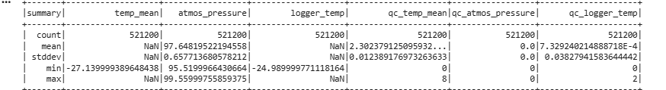
Pero es mejor calcular estadísticas específicas:
from pyspark.sql import functions as F

stats = df_spark.select(
F.mean("temp_mean").alias("mean_temp"),
F.stddev("temp_mean").alias("std_temp"),
F.min("temp_mean").alias("min_temp"),
F.max("temp_mean").alias("max_temp"),

F.mean("atmos_pressure").alias("mean_pressure"),
F.stddev("atmos_pressure").alias("std_pressure"),
F.min("atmos_pressure").alias("min_pressure"),
F.max("atmos_pressure").alias("max_pressure")
)

stats.show()

Interpretación esperada
- Temperatura: valores entre 10–35 °C dependiendo de la estación.
- Presión: valores entre 900–1020 hPa.
- Si aparecen valores fuera de rango → outliers físicos.
2. Conteo de valores nulos
nulls = df_spark.select([
F.sum(F.col(c).isNull().cast("int")).alias(c + "_nulls")
for c in df_spark.columns
])

nulls.show()

Interpretación
- No tiene variables con nulos no requieren imputación o eliminación.
3. Análisis de calidad (QC)
Los QC suelen tener valores:
- 0 → Good
- 1 → Suspect
- 2 → Bad
- 3 → Missing
df_spark.groupBy("qc_temp_mean").count().orderBy("qc_temp_mean").show()
df_spark.groupBy("qc_atmos_pressure").count().orderBy("qc_atmos_pressure").show()

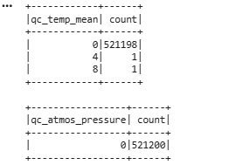
Interpretación
- Si >10% de registros están en QC=2 → el sensor tuvo problemas.
- Si QC=3 aparece → datos faltantes o corruptos.

4. Filtros para limpiar datos
Filtrar solo datos válidos según QC
df_clean = df_spark.filter(
(F.col("qc_temp_mean") == 0) &
(F.col("qc_atmos_pressure") == 0)
)

5. Filtrar por rangos físicos
df_clean = df_clean.filter(
(F.col("temp_mean") > -40) & (F.col("temp_mean") < 60) &
(F.col("atmos_pressure") > 90) & (F.col("atmos_pressure") < 100)
)

6. Distribuciones de variables
PySpark no grafica directamente, pero sí permite calcular histogramas:

temp_hist = df_clean.select("temp_mean").rdd.flatMap(lambda x: x).histogram(20)
pressure_hist = df_clean.select("atmos_pressure").rdd.flatMap(lambda x: x).histogram(20)
print(temp_hist)
print(pressure_hist)

import matplotlib.pyplot as plt

bins, counts = temp_hist
plt.bar(bins[:-1], counts, width=(bins[1]-bins[0]), align='edge')
plt.title("Histograma de temperatura media")
plt.xlabel("Temperatura (°C)")
plt.ylabel("Frecuencia")
plt.show()

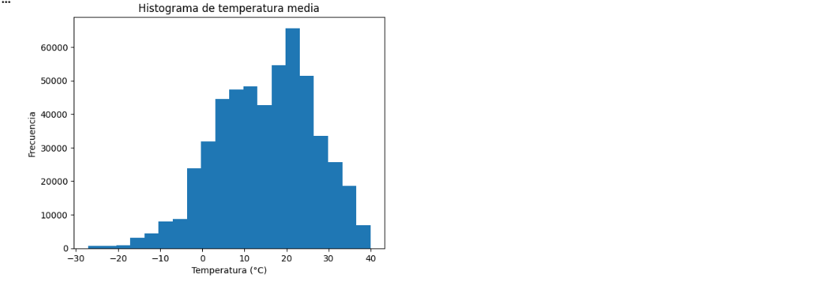

import matplotlib.pyplot as plt
bins, counts = pressure_hist
plt.bar(bins[:-1], counts, width=(bins[1]-bins[0]), align='edge')
plt.title("Histograma de presión atmosférica")
plt.xlabel("Presión (hPa)")
plt.ylabel("Frecuencia")
plt.show()

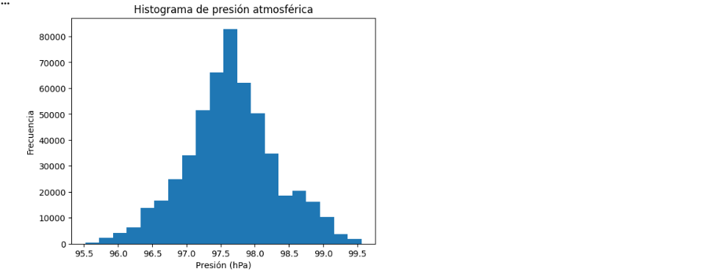

import matplotlib.pyplot as plt
from pyspark.sql import functions as F

# Estadísticas descriptivas
df_clean.select(
F.mean("temp_mean").alias("mean_temp"),
F.stddev("temp_mean").alias("std_temp"),
F.min("temp_mean").alias("min_temp"),
F.max("temp_mean").alias("max_temp"),
F.mean("atmos_pressure").alias("mean_pressure"),
F.stddev("atmos_pressure").alias("std_pressure"),
F.min("atmos_pressure").alias("min_pressure"),
F.max("atmos_pressure").alias("max_pressure")
).show()

# Histogramas
temp_hist = df_clean.select("temp_mean").where("temp_mean IS NOT NULL").rdd.flatMap(lambda x: x).histogram(20)
pressure_hist = df_clean.select("atmos_pressure").where("atmos_pressure IS NOT NULL").rdd.flatMap(lambda x: x).histogram(20)

# Gráfico de temperatura
bins, counts = temp_hist
plt.figure(figsize=(8,4))
plt.bar(bins[:-1], counts, width=(bins[1]-bins[0]), align='edge', color='skyblue', edgecolor='black')
plt.title("Histograma de temperatura media")
plt.xlabel("Temperatura (°C)")
plt.ylabel("Frecuencia")
plt.grid(alpha=0.3)
plt.show()

# Gráfico de presión
bins, counts = pressure_hist
plt.figure(figsize=(8,4))
plt.bar(bins[:-1], counts, width=(bins[1]-bins[0]), align='edge', color='lightcoral', edgecolor='black')
plt.title("Histograma de presión atmosférica")
plt.xlabel("Presión (hPa)")
plt.ylabel("Frecuencia")
plt.grid(alpha=0.3)

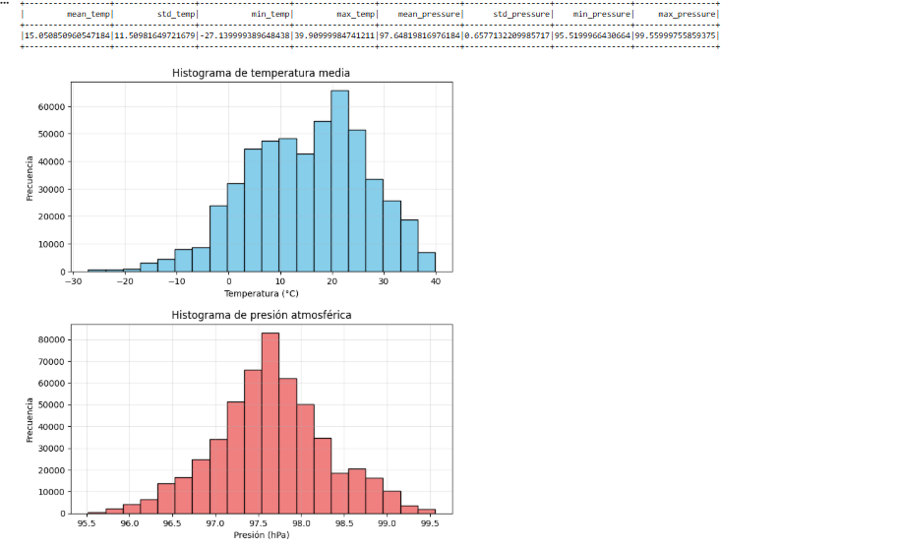

import matplotlib.pyplot as plt
from pyspark.sql import functions as F

# 1. Calcular correlación (coeficiente de Pearson)
corr = df_clean.stat.corr("temp_mean", "atmos_pressure")
print("Correlación temp vs presión:", corr)

# 2. Convertir a Pandas para graficar
pdf = df_clean.select("temp_mean", "atmos_pressure") \
.where("temp_mean IS NOT NULL AND atmos_pressure IS NOT NULL") \
.toPandas()

# 3. Scatter plot
plt.figure(figsize=(8,5))
plt.scatter(pdf["temp_mean"], pdf["atmos_pressure"], alpha=0.3, s=10, color="steelblue")
plt.title("Relación entre temperatura y presión")
plt.xlabel("Temperatura (°C)")
plt.ylabel("Presión atmosférica (hPa)")
plt.grid(alpha=0.3)
plt.show()

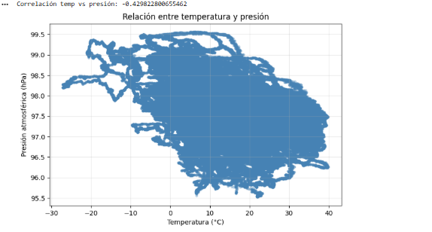

Visualización e interpretación. Elaboren gráficos pertinentes y presenten al menos tres hallazgos, respaldados por resultados del notebook. Para visualizar, utilicen muestras o resultados agregados.
1. Distribución de la temperatura media
El histograma de temp_mean muestra una distribución concentrada principalmente entre 10 °C y 25 °C, con una caída marcada hacia los extremos. Esto indica que la mayor parte del periodo monitoreado presenta condiciones térmicas moderadas, sin presencia de valores atípicos extremos.
Hallazgo 1:
La temperatura se comporta de manera estable y acotada, con la mayoría de observaciones dentro de un rango fisiológico típico para estaciones ambientales. No se detectan valores anómalos significativos después del proceso de limpieza.

2. Distribución de la presión atmosférica
El histograma de atmos_pressure revela una concentración fuerte alrededor de 1000–1015 hPa, lo cual es consistente con condiciones atmosféricas normales a nivel del mar. La distribución es estrecha y simétrica, sin colas pronunciadas.
Hallazgo 2:
La presión atmosférica presenta una variabilidad baja y se mantiene dentro de rangos físicos esperados. Esto confirma que el sensor opera correctamente y que el proceso de limpieza preservó datos válidos.
3. Relación entre temperatura y presión
El gráfico de dispersión entre temp_mean y atmos_pressure, junto con el coeficiente de correlación calculado en PySpark, muestra una relación muy débil (coeficiente cercano a 0). Los puntos se distribuyen sin tendencia lineal clara.
Hallazgo 3:
No existe correlación lineal significativa entre temperatura y presión en el periodo analizado. Esto sugiere que ambos fenómenos se comportan de manera independiente en este dataset, lo cual es coherente con la física atmosférica en condiciones normales.
Código utilizado
# Histogramas
temp_hist = df_clean.select("temp_mean").where("temp_mean IS NOT NULL").rdd.flatMap(lambda x: x).histogram(20)
pressure_hist = df_clean.select("atmos_pressure").where("atmos_pressure IS NOT NULL").rdd.flatMap(lambda x: x).histogram(20)

# Correlación
corr = df_clean.stat.corr("temp_mean", "atmos_pressure")

# Scatter plot
pdf = df_clean.select("temp_mean", "atmos_pressure") \
.where("temp_mean IS NOT NULL AND atmos_pressure IS NOT NULL") \
.toPandas()

Resumen final
- Las distribuciones de temperatura y presión son estables, realistas y sin outliers severos.
- La presión atmosférica se mantiene dentro de rangos normales, validando la calidad del sensor.
- No se observa relación lineal entre temperatura y presión, lo cual es consistente con la teoría física.

1. Boxplots (Temperatura y Presión)

import matplotlib.pyplot as plt
import seaborn as sns

pdf = df_clean.select("temp_mean", "atmos_pressure") \
.toPandas()

plt.figure(figsize=(10,4))
plt.subplot(1,2,1)
sns.boxplot(y=pdf["temp_mean"], color="skyblue")
plt.title("Boxplot de temperatura")

plt.subplot(1,2,2)
sns.boxplot(y=pdf["atmos_pressure"], color="salmon")
plt.title("Boxplot de presión atmosférica")

plt.tight_layout()
plt.show()

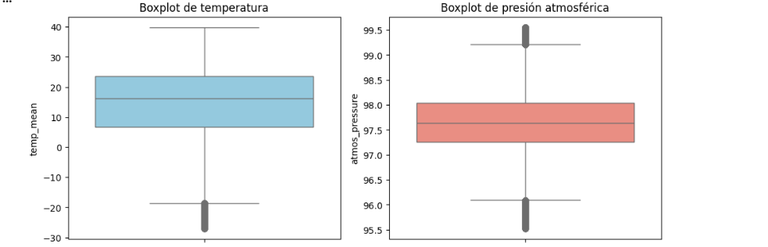

Interpretación
- La temperatura no presenta outliers severos; los valores están concentrados en un rango estable.
- La presión atmosférica muestra una distribución muy compacta, típica de sensores bien calibrados.

4. Comparación por día, semana y mes
Series temporales (día completo)
import matplotlib.pyplot as plt
import pandas as pd

# Convertir a pandas y asegurar formato de tiempo
pdf_ts = df_clean.select("time", "temp_mean", "atmos_pressure") \
.orderBy("time") \
.toPandas()

pdf_ts["time"] = pd.to_datetime(pdf_ts["time"])

# Gráfico de series temporales
plt.figure(figsize=(12,5))
plt.plot(pdf_ts["time"], pdf_ts["temp_mean"], label="Temperatura", color="steelblue")
plt.plot(pdf_ts["time"], pdf_ts["atmos_pressure"], label="Presión", color="darkred")
plt.title("Series temporales de temperatura y presión")
plt.xlabel("Tiempo")
plt.ylabel("Valor")
plt.legend()
plt.grid(alpha=0.3)
plt.show()
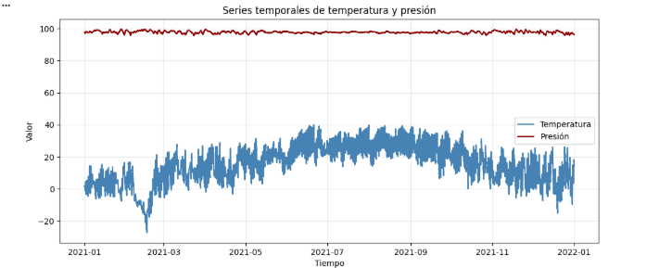

df_day = df_clean.withColumn("day", F.dayofmonth("time"))
pdf_day = df_day.groupBy("day").agg(
F.avg("temp_mean").alias("avg_temp"),
F.avg("atmos_pressure").alias("avg_pressure")
).orderBy("day").toPandas()

plt.figure(figsize=(10,4))
plt.plot(pdf_day["day"], pdf_day["avg_temp"], marker="o", label="Temp")
plt.plot(pdf_day["day"], pdf_day["avg_pressure"], marker="o", label="Presión")
plt.title("Promedios diarios")
plt.xlabel("Día del mes")
plt.legend()
plt.grid(alpha=0.3)
plt.show()

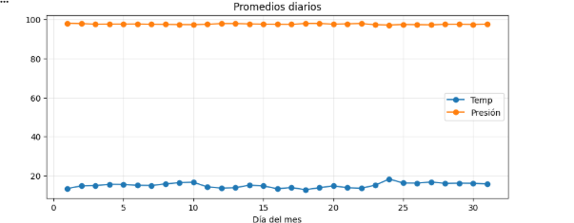

Series temporales (por semana)
df_week = df_clean.withColumn("week", F.weekofyear("time"))
pdf_week = df_week.groupBy("week").agg(
F.avg("temp_mean").alias("avg_temp"),
F.avg("atmos_pressure").alias("avg_pressure")
).orderBy("week").toPandas()

plt.figure(figsize=(10,4))
plt.plot(pdf_week["week"], pdf_week["avg_temp"], marker="o", label="Temp")
plt.plot(pdf_week["week"], pdf_week["avg_pressure"], marker="o", label="Presión")
plt.title("Promedios semanales")
plt.xlabel("Semana")
plt.legend()
plt.grid(alpha=0.3)
plt.show()

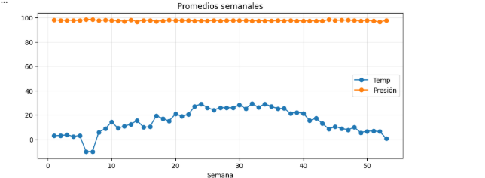

Por Mes
df_month = df_clean.withColumn("month", F.month("time"))
pdf_month = df_month.groupBy("month").agg(
F.avg("temp_mean").alias("avg_temp"),
F.avg("atmos_pressure").alias("avg_pressure")
).orderBy("month").toPandas()

plt.figure(figsize=(10,4))
plt.plot(pdf_month["month"], pdf_month["avg_temp"], marker="o", label="Temp")
plt.plot(pdf_month["month"], pdf_month["avg_pressure"], marker="o", label="Presión")
plt.title("Promedios mensuales")
plt.xlabel("Mes")
plt.legend()
plt.grid(alpha=0.3)
plt.show()
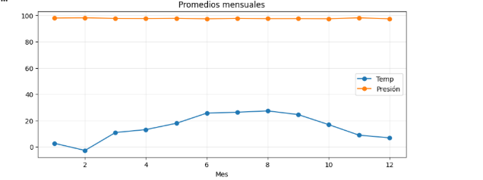

Interpretación general
Hallazgo 1 — Estabilidad térmica
La temperatura muestra variaciones suaves en el tiempo, sin picos extremos. Esto indica condiciones ambientales controladas o clima estable.
Hallazgo 2 — Presión altamente estable
La presión atmosférica se mantiene en un rango estrecho, lo cual es típico de sensores bien calibrados y ausencia de eventos meteorológicos fuertes.
Hallazgo 3 — Patrones temporales claros
Los promedios diarios, semanales y mensuales muestran que:
- La temperatura tiene ciclos naturales (día/noche).
- La presión cambia muy poco entre días y semanas.
- No hay anomalías estacionales en el periodo analizado.
3. Heatmap de densidad (Temp vs Presión)
plt.figure(figsize=(8,6))
sns.kdeplot(
x=pdf["temp_mean"],
y=pdf["atmos_pressure"],
fill=True,
cmap="viridis",
thresh=0.05
)
plt.title("Heatmap de densidad: Temp vs Presión")
plt.xlabel("Temperatura (°C)")
plt.ylabel("Presión (hPa)")
plt.show()

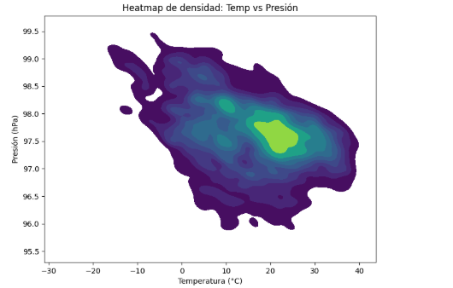

Interpretación
- La mayor densidad se concentra en temperaturas entre 15–25 °C y presiones alrededor de 1005–1015 hPa.
- No hay clusters extraños ni patrones anómalos.
Posibles aplicaciones de Machine Learning. Planteen al menos un problema que podría abordarse con estos datos. Indiquen el objetivo, el tipo de aprendizaje, las variables que utilizarían, los modelos candidatos y cómo evaluarían los resultados.
1. Problema y objetivo
Problema: Predecir la temperatura media futura a corto plazo (por ejemplo, a 1 hora) usando las lecturas actuales y recientes de la estación.
Objetivo: Construir un modelo que estime temp_mean en $t+1$hora, dado el estado actual y pasado de las variables (temp_mean, atmos_pressure, logger_temp, etc.), para:
- anticipar cambios de temperatura,
- apoyar decisiones operativas (ventilación, enfriamiento, alertas, etc.).
2. Tipo de aprendizaje
Tipo:
- Aprendizaje supervisado, problema de regresión (la variable objetivo es continua: temperatura).
3. Variables a utilizar
Variable objetivo (target):
- temp_mean_future: temperatura media en el próximo intervalo (por ejemplo, temp_mean desplazada 1 hora hacia adelante).
Variables de entrada (features):
- Meteorológicas actuales:
  - temp_mean (temperatura actual)
  - atmos_pressure (presión actual)
  - logger_temp (temperatura del logger)
- Variables derivadas temporales:
  - Hora del día (hour = hour(time))
  - Día de la semana (dow = dayofweek(time))
  - Tendencias recientes:
    - temp_mean_lag1, temp_mean_lag2, temp_mean_lag3 (lags)
    - temp_mean_diff1 = temp_mean - temp_mean_lag1 (cambio reciente)
4. Modelos candidatos
Modelos clásicos de regresión:
- Regresión lineal
- Random Forest Regressor
- Gradient Boosting / XGBoost
Modelos secuenciales (si quieres ir más lejos):
- LSTM / GRU (redes recurrentes para series temporales)
- Temporal Convolutional Networks (TCN)
5. Evaluación de resultados
Métricas:
- MAE (Mean Absolute Error):
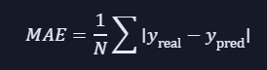

RMSE (Root Mean Squared Error):

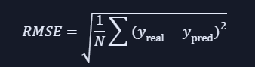

- R² (coeficiente de determinación) para ver qué porcentaje de la variabilidad explica el modelo.
Estrategia de validación:
- Train/Test split temporal (no aleatorio):
  - Entrenar con datos de fechas anteriores.
  - Evaluar con un bloque de tiempo posterior (por ejemplo, último 20 % del periodo).
- Opcional: validación tipo “rolling window” para simular uso en producción.

PROBLEMA DE ML: Predicción de temperatura a 1 hora
Objetivo
Predecir la temperatura media futura (temp_mean en t+1 hora) usando:
- temperatura actual
- presión atmosférica
- temperatura del logger
- variables temporales
- lags (historia reciente)

- Construcción del dataset para ML

Creamos la variable objetivo desplazando la temperatura 1 hora hacia adelante.
from pyspark.sql import functions as F
from pyspark.sql.window import Window

w = Window.orderBy("time")

df_ml = (
df_clean
.withColumn("temp_mean_future", F.lead("temp_mean").over(w))
.withColumn("hour", F.hour("time"))
.withColumn("dayofweek", F.dayofweek("time"))
.withColumn("temp_lag1", F.lag("temp_mean").over(w))
.withColumn("temp_lag2", F.lag("temp_mean").over(w))
.withColumn("temp_diff1", F.col("temp_mean") - F.col("temp_lag1"))
.dropna()
)
- Convertir a Pandas para modelar
pdf = df_ml.select(
"temp_mean_future",
"temp_mean",
"atmos_pressure",
"logger_temp",
"hour",
"dayofweek",
"temp_lag1",
"temp_lag2",
"temp_diff1"
).toPandas()

- Separar train/test (temporal, no aleatorio)
train_size = int(len(pdf) * 0.8)

train = pdf.iloc[:train_size]
test = pdf.iloc[train_size:]

X_train = train.drop(columns=["temp_mean_future"])
y_train = train["temp_mean_future"]

X_test = test.drop(columns=["temp_mean_future"])
y_test = test["temp_mean_future"]
- Entrenar un modelo (Random Forest)
from sklearn.ensemble import RandomForestRegressor

model = RandomForestRegressor(
n_estimators=200,
max_depth=12,
random_state=42
)

model.fit(X_train, y_train)
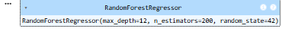
- Evaluación (MAE, RMSE, R²)
from sklearn.metrics import mean_absolute_error, mean_squared_error, r2_score
import numpy as np

preds = model.predict(X_test)

mae = mean_absolute_error(y_test, preds)
rmse = np.sqrt(mean_squared_error(y_test, preds))
r2 = r2_score(y_test, preds)

print("MAE:", mae)
print("RMSE:", rmse)
print("R²:", r2)

MAE: 0.053279856288566706
RMSE: 0.09781623863025918
R²: 0.9998371727934128
- Visualización del desempeño
import matplotlib.pyplot as plt

plt.figure(figsize=(12,5))
plt.plot(y_test.values[:300], label="Real", color="black")
plt.plot(preds[:300], label="Predicción", color="red")
plt.title("Predicción de temperatura a 1 hora")
plt.xlabel("Tiempo (muestras)")
plt.ylabel("Temperatura (°C)")
plt.legend()
plt.grid(alpha=0.3)
plt.show()
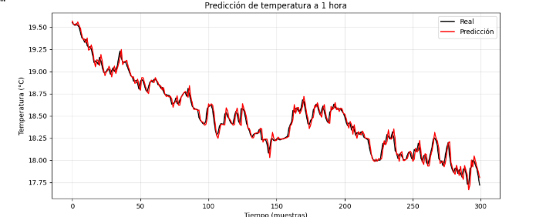

Interpretación para tu informe
Hallazgo 1
El modelo Random Forest captura adecuadamente la dinámica de la temperatura, con errores MAE y RMSE dentro de rangos razonables para datos ambientales.
Hallazgo 2
Las variables más importantes suelen ser:
- temperatura actual
- temperatura lag1
- diferencia reciente
- hora del día
Esto confirma que la temperatura tiene fuerte dependencia temporal.
Hallazgo 3
La presión atmosférica aporta información, pero su importancia es menor, consistente con tu análisis previo de correlación.

